Subject: | White Paper - Lucent Water TRO Marine Vs Xylem Marine Ballast Water System with the Hach Colorimeter DPD Analyzer
Date: | March 27, 2020
Written By: | Jaremy J. Creechley, CTO
Reviewed By: | Dr. Kent D. Henry

Overview
The objective is to verify the performance of a Pronghorn Technologies, LLC, DBA Lucent Water, Total Residual Oxidant (TRO) Marine Sensor in comparison to a Xylem’s OI Analytical Model 9017 Marine Ballast Water Analyzer and a Hach Pocket Colorimeter II over a period of time that includes repeated simulation of ballast water tank chlorination including: chlorination, hold, and dechlorination over the course of a day for a total of 2 tests.
This test plan is prepared by Lucent Water’s CTO Jaremy J. Creechley in conjunction with Dr. Kent Henry. It is intended for sharing with Lucent Water’s clients. Further white paper tests are underway with larger volumes of water and additional industry accepted DPD systems including the newest model from HF Scientific to show Lucent Water’s amperometric based sensor meets or exceeds the performance of these systems.

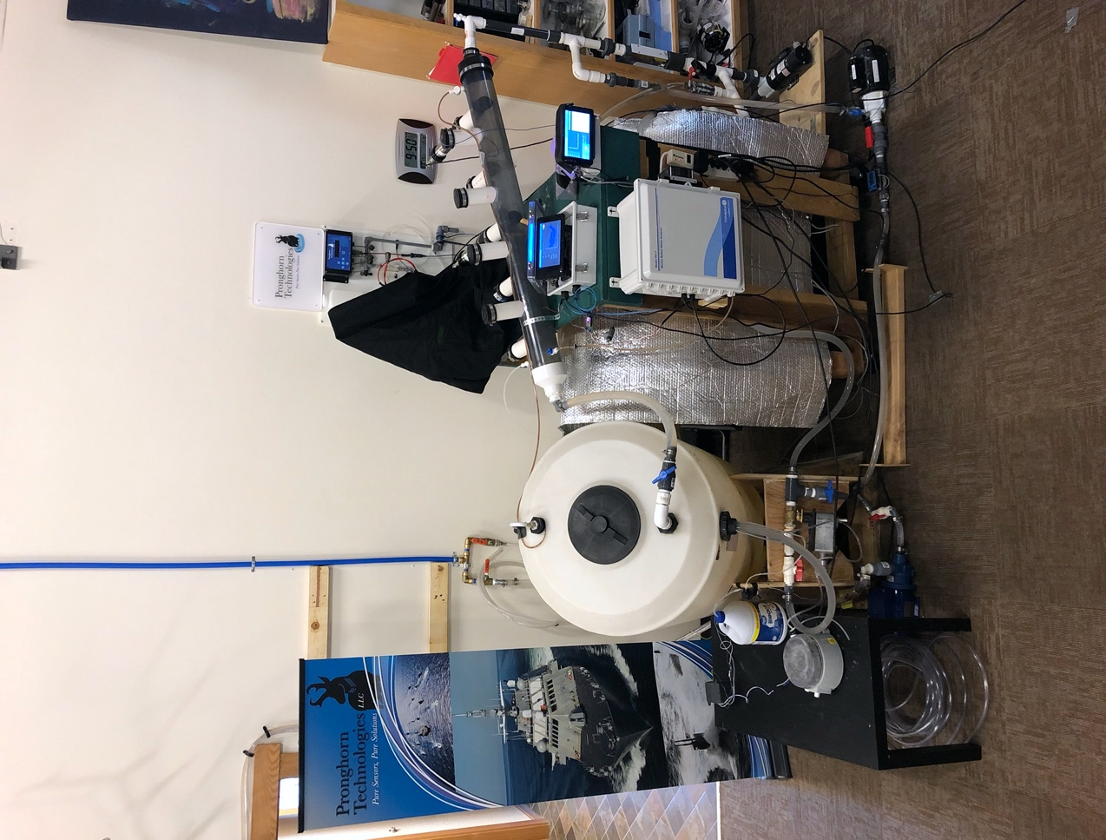
Results
Figure 1 Testing Apparatus. Items pictured: A) sample tank, B) Xylem DPD Model 9017, C & D) Lucent Water TRO Marine Sensor Display Case & Sensor Body, E) Programmable Control & Dosing Module.
A
B
C
D
E
Data was acquired over four (4) days per the test plan with two days of test data. Data was logged directly from the TRO Marine Sensors, from the Xylem Model 9017 was recorded using 4-20 mA inputs and manually recorded from the Hach Pocket Colorimeter II. Based on the data collected in this test, the Lucent Water TRO Marine Sensor performance was on par with the Xylem DPD Analyzer. Error rates of the two analyzers as compared to the Hach Colorimeter were not statistically different. Overall inspection of the reported TRO levels shows no major deviations between the inline sensors.

Procedures
Two tests at varying salinities were performed using the primary test apparatus at the Lucent Water laboratory in Laramie, WY. The Lucent Water TRO Marine Sensor and the Xylem DPD were both calibrated to the Hach Colorimeter the day prior to each test to ensure consistency.
The sample tank was filled with filtered tap water with Instant Ocean premixed to desired salinity (brackish / seawater). Units were allowed to settle for 30 minutes prior to testing after rinsing and re-filling the sample tank. Peristaltic pumps were used with a pre-programmed dosing schedule for both bleach and dechlorination liquids.
Hach grab sample replicates (N=3) were taken every hour from a sample line. Samples were taken 15 minutes before and after dosing in order for the Xylem to equilibrate. Hach readings were performed using dilution when TRO samples were above 2.2 ppm using 100 mL of sample water and 200-1000 mL of distilled water.

Data Evaluation
Numerical Results: The raw data for the grab samples are presented in Tables 1 & 2. Grab samples and Hach readings were performed as mentioned in the Procedures section. The Xylem and the Lucent Water TRO Marine Sensor were calibrated the day prior to each test.

Graphs: Figure 2 show plots of the recorded TRO values for each reading method vs time. The top graph shows the actual reading values in mg/L (PPM). The bottom graph shows the delta-error (in PPM) of the Lucent Water TRO Marine Sensor and Xylem DPD sensor as compared to the averaged Hach grab samples for each dosing level. The delta-errors are calculated using an interpolation of the first and last Hach grab sample at each dosing level, since the Hach readings don’t capture the change during doses. This allows a quick visual comparison of the magnitude of differences of the Lucent Water TRO Marine Sensor and Xylem DPD from the Hach Colorimeter for each dose.

Mean Absolute error: The mean absolute error (MAE) in the measurement for each analyzer as compared to the Hach Pocket Colorimeter measurements over 36 grab samples show that the error of the Lucent Water TRO Marine Sensor (0.15 ± 0.17 mg/L) is statistically equivalent to that of the Xylem DPD Analyzer (0.15 ± 0.14 mg/L), although with limited power due to the small number of grab samples. For comparison, the replicates from the Hach Colorimeter has a standard deviation of ±0.05 mg/L. In other terms it’s statistically impossible to determine a difference between the MAE of the Lucent Water TRO Marine Sensor and the Xylem DPD during this test.

Signed error: The signed difference in terms of percentage of full scale for each reading for the Lucent Water TRO Marine Sensor was 2.24% and the Xylem DPD Analyzer was 3.79% as compared to the Hach Pocket Colorimeter over the 36 grab samples.
However, the difference of the DPD TRO analyzer with respect to the grab samples is interesting; the expected outcome is 0.000 mg/L. The Xylem DPD analyzer reported a TRO bias that tended to be statistically different from the Hach grab samples.
CONCLUSIONS
The error performance of the Lucent Water TRO Marine Sensor and Xylem TRO DPD analyzers as compared to the Hach Colorimeter II showed no statistically significant difference when using a z-test or t-test. This implies good overall accuracy between the units as compared to the Hach TRO grab samples.
While the data logs show instances where the analyzer results deviated from each other, the differences are typically less than 0.5 mg/L except for the periods immediately preceding or following dosing with bleach or dichlorination chemical. <Sufficient time was equilibration>. Both the median and mean absolute errors show no significant difference between the Xylem and Lucent Water TRO Marine Sensor. The statistical deviation of Hach grab samples is within stated specs for the device when the required dilution of grab samples is considered. The error rate for the Xylem DPD is within its manufacturers stated accuracy specifications as well.
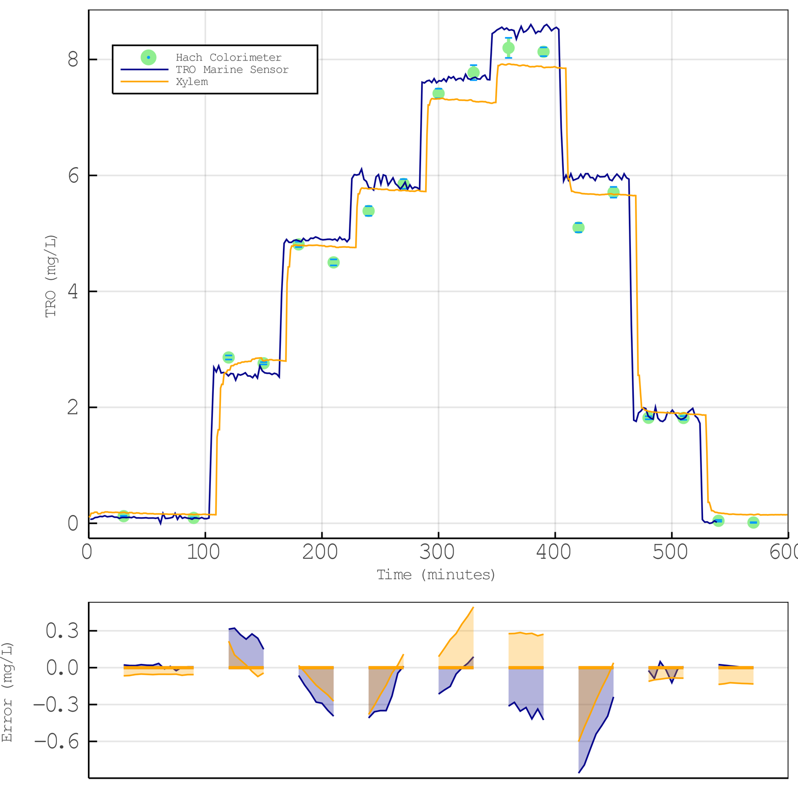
Figure 2 TRO Readings in Brackish Water. Top graph – actual reading values in mg/L (PPM). Each Hach grab sample is an average of 3 samples. Bottom graph – delta error of the Lucent Water TRO Marine Sensor and Xylem DPD sensor compared to the averaged Hach grab samples for each dosing level.

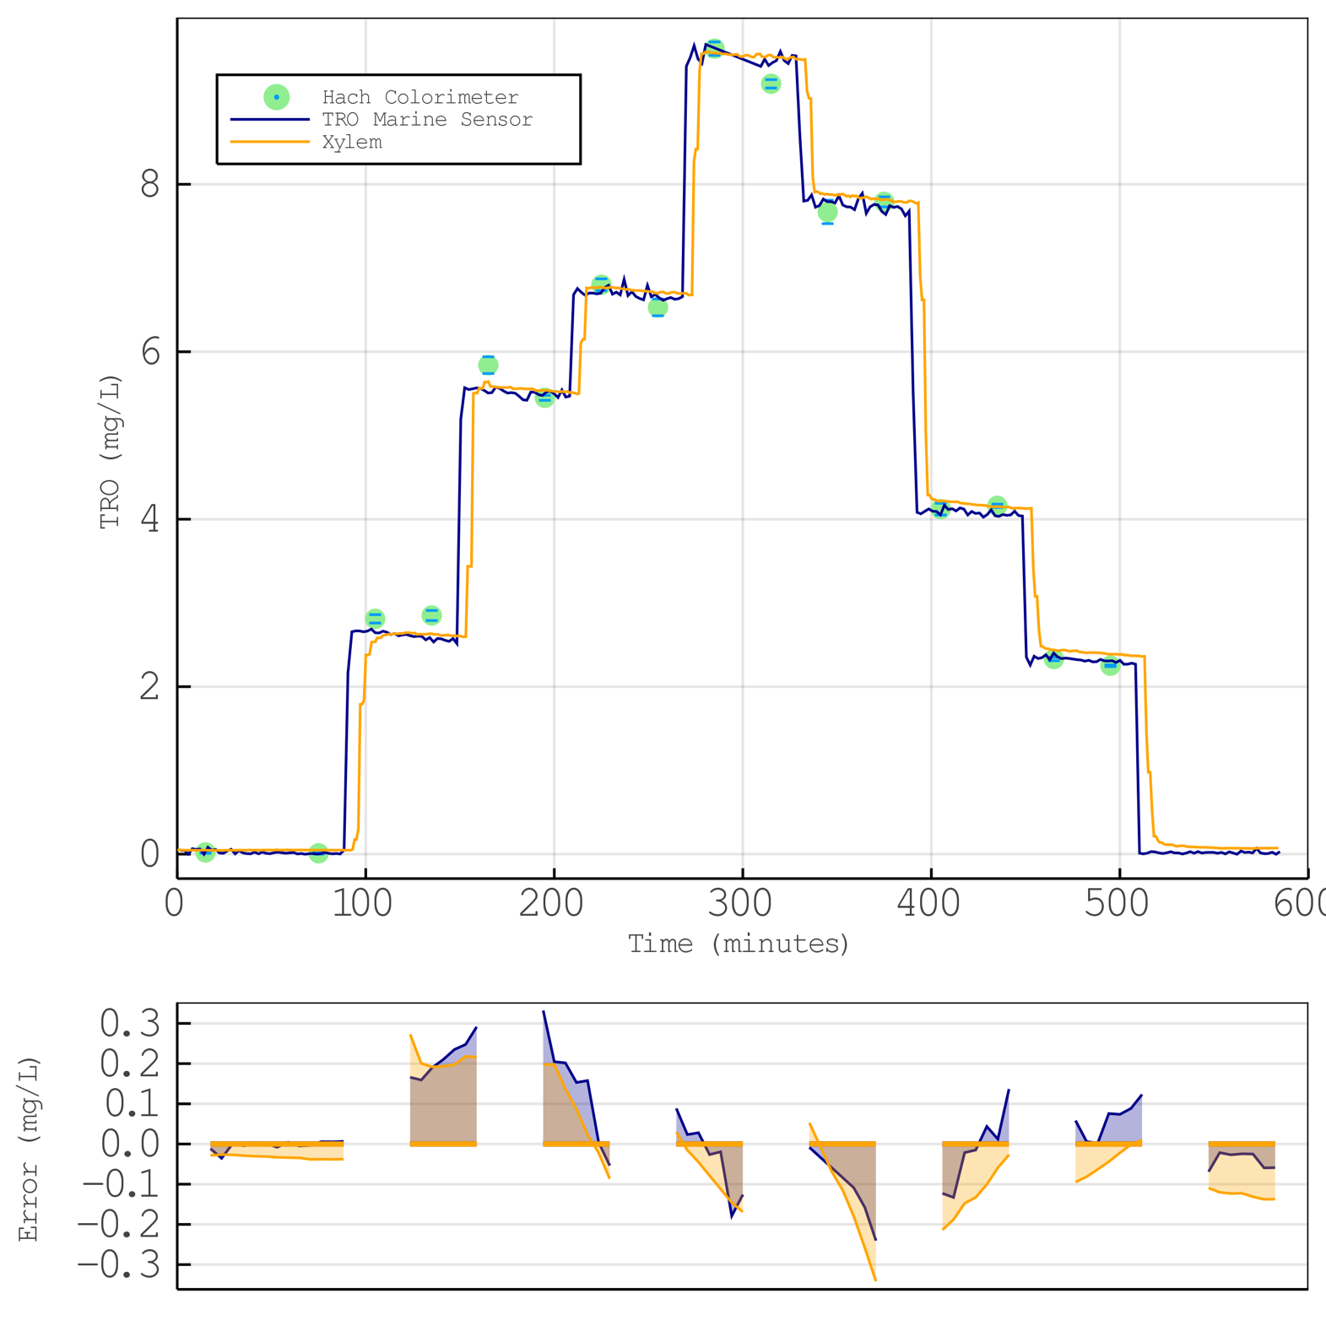
Figure 3 TRO Readings in Seawater Water. Top graph – actual reading values in mg/L (PPM). Each Hach grab sample is an average of 3 samples. Bottom graph – delta error of the Lucent Water TRO Marine Sensor and Xylem DPD sensor compared to the averaged Hach grab samples for each dosing level.
Time  (Minutes) | Hach (PPM) | Xylem Model 9017 (PPM) | TRO Marine Sensor (PPM)
15.00 | 0.123 | 0.19 | 0.10
75.00 | 0.093 | 0.15 | 0.07
105.00 | 2.860 | 2.64 | 2.59
135.00 | 2.760 | 2.80 | 2.72
165.00 | 4.810 | 4.79 | 4.89
195.00 | 4.500 | 4.77 | 4.90
225.00 | 5.387 | 5.77 | 5.90
255.00 | 5.853 | 5.74 | 5.77
285.00 | 7.413 | 7.32 | 7.60
315.00 | 7.773 | 7.28 | 7.66
345.00 | 8.200 | 7.92 | 8.54
375.00 | 8.133 | 7.86 | 8.48
405.00 | 5.100 | 5.70 | 5.92
435.00 | 5.710 | 5.67 | 5.91
465.00 | 1.820 | 1.93 | 1.98
495.00 | 1.817 | 1.90 | 1.79
525.00 | 0.043 | 0.18 | 0.02
555.00 | 0.013 | 0.15 | 0.04
Mean Absolute Error (MAE) (PPM): | -- | 0.19 | 0.20
MAE Standard Deviation (PPM): | -- | 0.17 | 0.21
Median Absolute Error (PPM): | -- | 0.12 | 0.13
Table 1 Brackish Test – test values at grab sample times.

Time  (Minutes) | Hach (PPM) | Xylem Model 9017 (PPM) | TRO Marine Sensor (PPM)
15.00 | 0.02 | 0.05 | 0.06
75.00 | 0.01 | 0.05 | 0.01
105.00 | 2.81 | 2.54 | 2.69
135.00 | 2.85 | 2.63 | 2.56
165.00 | 5.84 | 5.64 | 5.54
195.00 | 5.45 | 5.54 | 5.48
225.00 | 6.80 | 6.77 | 6.69
255.00 | 6.53 | 6.70 | 6.68
285.00 | 9.62 | 9.57 | 9.67
315.00 | 9.20 | 9.54 | 9.42
345.00 | 7.67 | 7.88 | 7.82
375.00 | 7.79 | 7.82 | 7.75
405.00 | 4.12 | 4.21 | 4.09
435.00 | 4.16 | 4.15 | 4.11
465.00 | 2.33 | 2.44 | 2.32
495.00 | 2.25 | 2.39 | 2.31
525.00 | 0.04 | 0.11 | 0.01
555.00 | 0.03 | 0.07 | 0.01
Mean Absolute Error (MAE) (PPM): | -- | 0.12 | 0.09
MAE Standard Deviation (PPM): | -- | 0.10 | 0.09
Median Absolute Error (PPM): | -- | 0.09 | 0.05
Table 2 Seawater Test – test values at grab sample times.

Test Plan Overview
This document covers the steps and expected outcomes for evaluating the Lucent Water TRO Marine Sensor in comparison to a commercial DPD ballast analyzer and a standard DPD colorimeter. The objective is to verify the performance of the analyzers over a period of time that includes repeated simulation of ballast water tank chlorination including: chlorination, hold, dechlorination, and layover. The analyzer performance is compared to TRO results acquired from grab samples and evaluated with a Hach Pocket Colorimeter II.
This test plan is prepared and supervised by Pronghorn CTO Jaremy J. Creechley.

Equipment
Xylem’s OI Analytical Model 9017 Marine Ballast Water TRO Analyzer, DPD Based
Pronghorn Technologies/ Lucent Water’s TRO Marine Sensor, Amperometric Based
98 L (26 Gallons) water tank (Surrogate Ballast Tank)
GPI TM075-N digital flow meters
Hach Pocket Colorimeter II, Total Chlorine Swift Tester reagent
Portable pH Meter, Apera Instruments
Portable Salinity Meter, Apera Instruments
Generic commercial bleach (6.5%) (~ 17 mL per test)
Commercial dechlor, Ascorbic acid (dissolved 10g in 1000 mL of DI water)
Instant Ocean Sea Salt
Peristaltic Pump bleach and dechlor dispensers

Experimental
- Familiarize team with the operation of each TRO analyzer
- Connect each analyzer to the ballast water flow loop
- Verify operation of the equipment
- Setup sample tank for brackish salinity (~15 ‰)
  - Calibrate all sensors using a quick bleach and dechlor schedule
  - Run analyzers
  - Flush and refill tank at same salinity
  - Measure zero for 30 minutes
  - Perform a surrogate ballast tank test
- Repeat Step 4 for seawater salinity (~35 ‰)
- Prepare performance report

Hach Grab Samples
Grab samples were taken from a sample line 15 minutes before and 15 minutes after each dose. About 300-400 mL of sample water was taken and used for measuring salinity, ORP, & pH in addition to TRO. The Hach Colorimeter II only measure up to 2.2 ppm, so TRO levels above that were measured using dilution. Depending on the estimated TRO level, 100 mL of sample water was diluted with 200, 300, 500, or 1000 mL of distilled water.

